  - Create a VNET and Add 2 Subnets . 1st subnet named "PE-Subnet" for Private endpoint and other "AVD subnet" for AVD
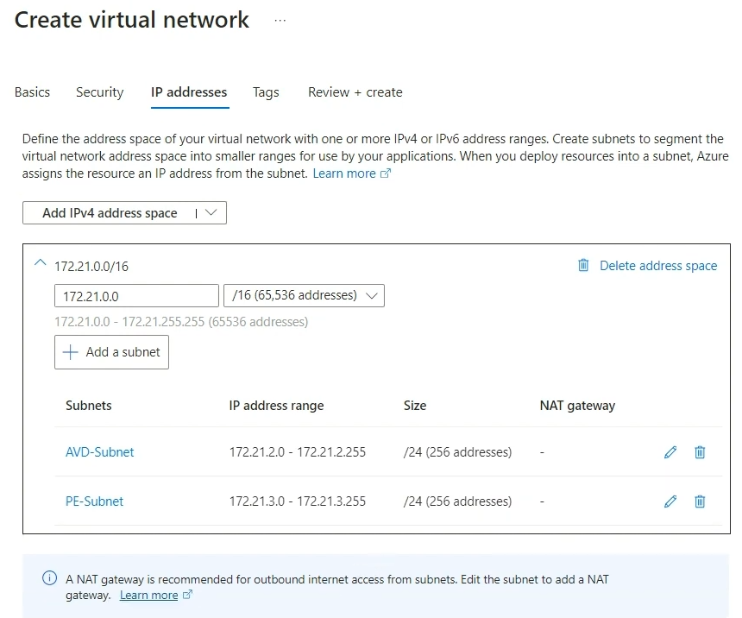
  - Create AVD by creating pool and adding machines .
  - Use the Previous created VNET and add the "AVD subnet " specificlaly created for AVD.

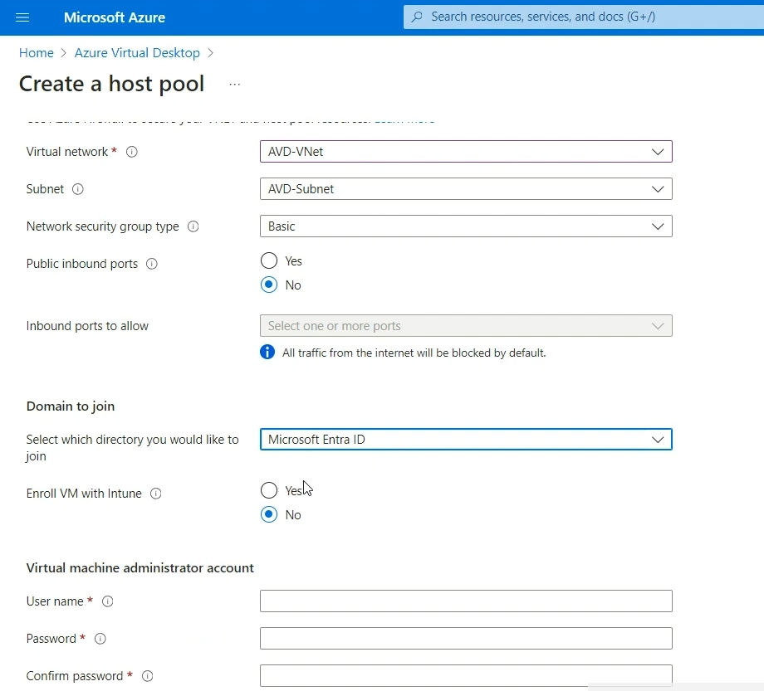

  - Note that we can set it up using ADDS or Azure AD . But to keep things simple we will use Entra ID (Azure AD)
  - Next create a Workspace for the AVD setup and add Register the DAG application Group just created by our new AVD setup. Then review and create
  - Also Application group add users or group required to access these resources
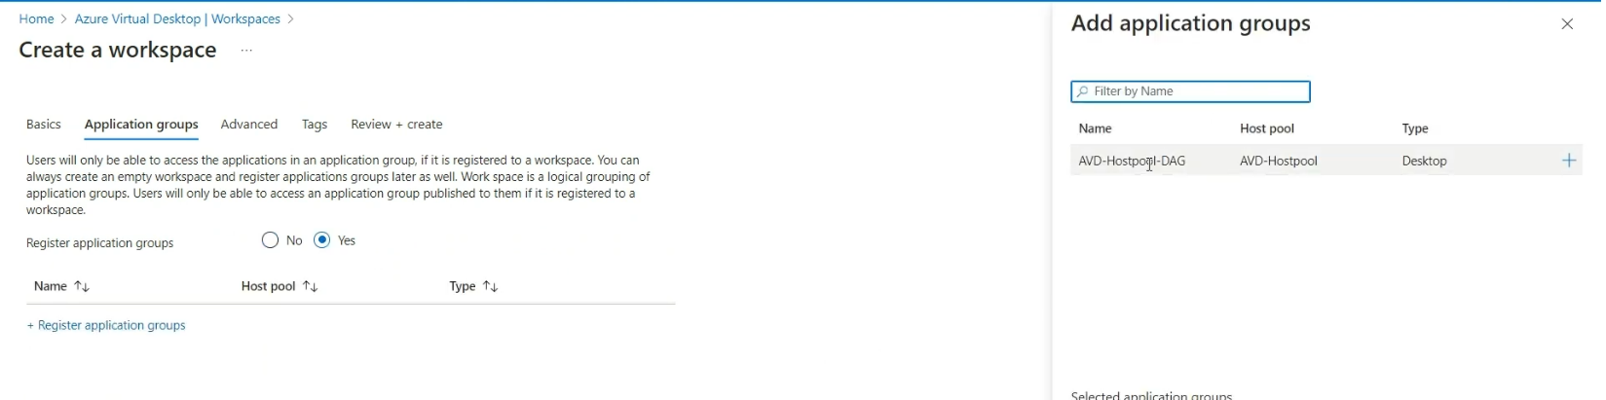

  - Create a NSG and attach it to "AVD" subnet
  - Create an outbound rule for AVD NSG just created mentioning Destination as "Service Tag " and Destination Service tag as "WindowsVirtualDesktop" and Service as HTTPS mentioning action Deny. (This rule will prevent any outbound access to AVD)
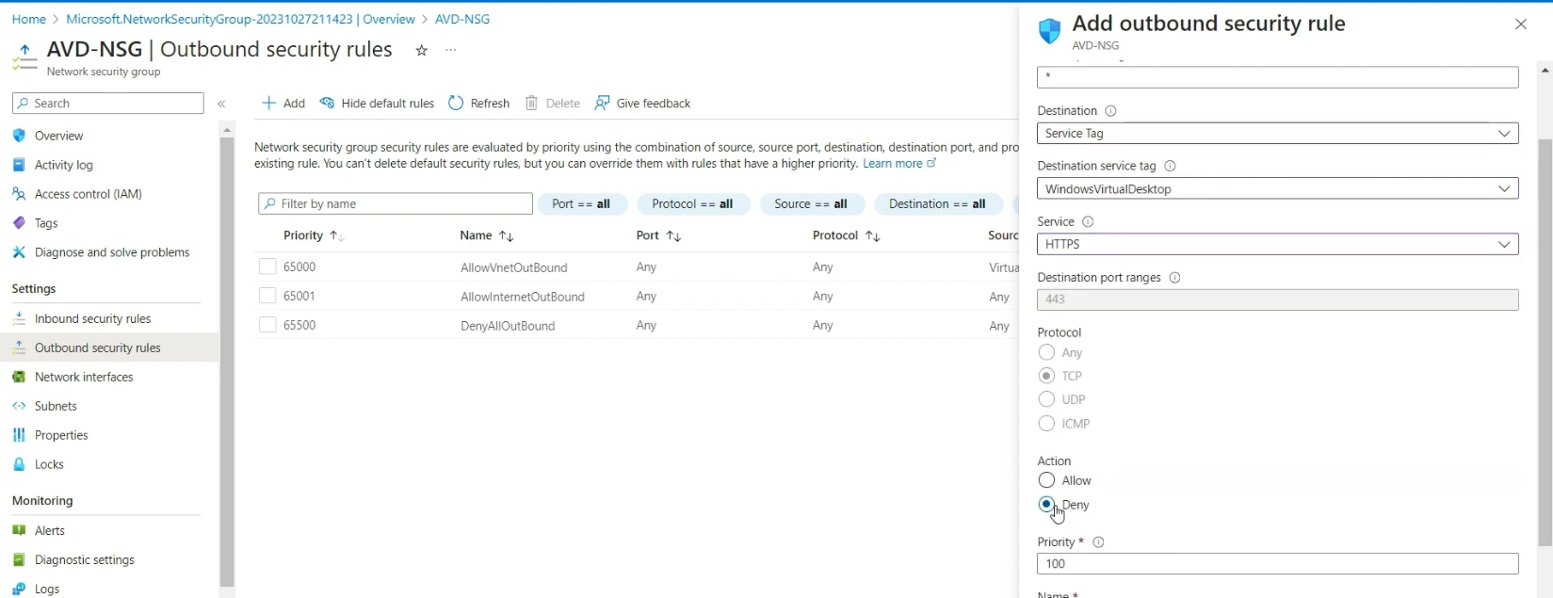

  - Associate the AVD NSG to a AVD Subnet so that Network rules could be applied to the AVD .
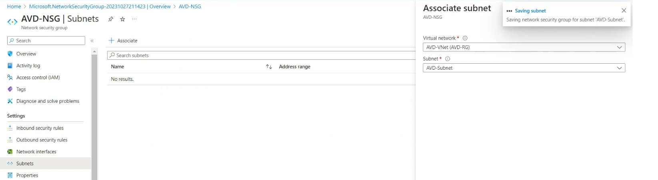
DISABLE PUBLIC ACCESS TO HostPOOL AND CREATE PRIVATE ENDPOINT
  - Goto Hostpool >>Networking >>Public Access and Select >> Disable Public access and USE private access.
  - At the same time in Hostpool >>Networking >> Private Endpoint connection >>create new Private Endpoint. Give Name and select "connection" as Target Sub-Resource .
  - In the Virtual network tab select Vnet and choose PE-Subnet for Subnet and save rest as it is.
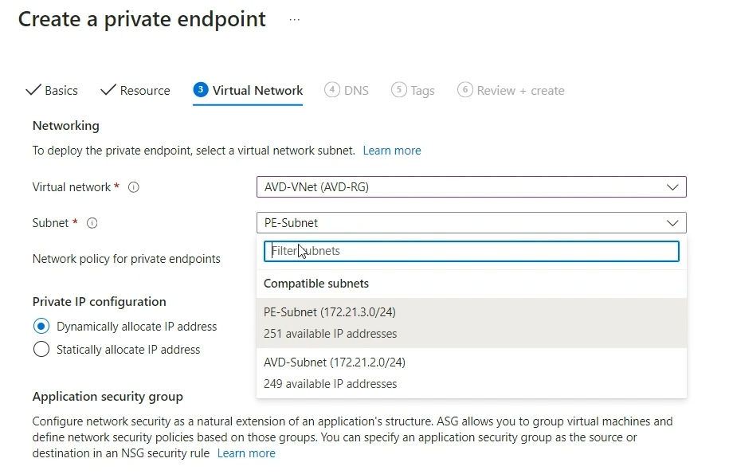

DISABLE PUBLIC ACCESS TO Workspace AND CREATE PRIVATE ENDPOINT
  - Goto Workspace >>Networking >>Public access and select>> Disable Public access and USE private access.
  - At the same time in Workspace>>Networking >> Private Endpoint connection >>create new Private Endpoint. Create 2 Private endpoints - One for feed and one for global.
  - In the Virtual network tab select Vnet and choose PE-Subnet for SUBNET and save rest as it is.
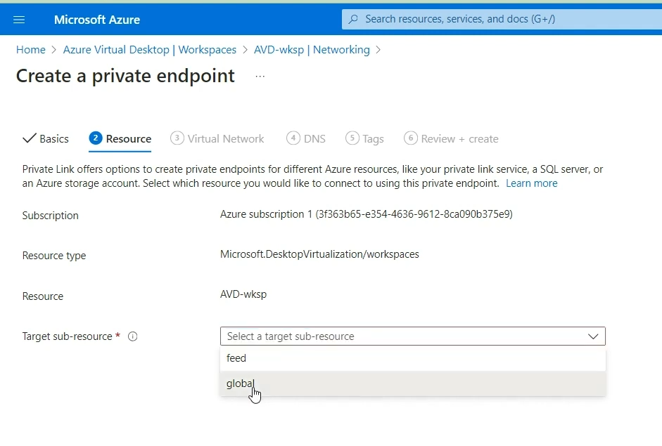

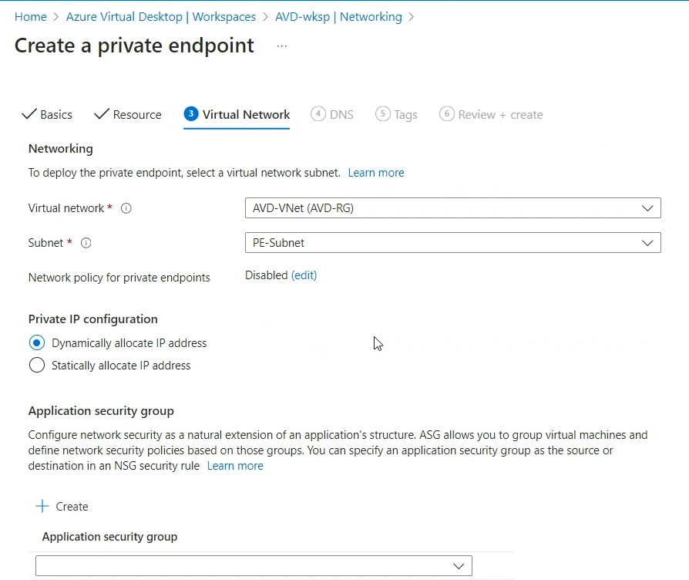

  - We can create a Stand alone VM as we don’t have a VPN setup or Site -site tunneling
The new VM's all public ports should be closed as we will use private Endpoint
We will Choose here "PE Subnet" for Subnet option and keep the same VNET from start for all options

